**A Complete Guide to Usage of ‘usermod’ command – 15 Practical Examples with Screenshots**

In Unix/Linux distributions, the command ‘**usermod**‘ is used to modify or change any attributes of a already created user account via command line. The command ‘**usermod**‘ is similar to that ‘**useradd**‘ or ‘**adduser**‘ but the login granted to an existing user.

[](https://www.tecmint.com/wp-content/uploads/2014/11/usermod-command.png)15 usermod Command Examples

The command ‘**useradd**‘ or ‘**adduser**‘ is used for creating user accounts in Linux systems. To know more about on how to create system users, read our complete guide at:

After creating user accounts, in some scenarios where we need to change the attributes of an existing user such as, change user’s home directory, login name, login shell, password expiry date, etc, where in such case ‘usermod’ command is used.

When we execute ‘usermod‘ command in terminal, the following files are used and affected.

1. **/etc/passwd** – User account information.
2. **/etc/shadow** – Secure account information.
3. **/etc/group** – Group account information.
4. **/etc/gshadow** – Secure group account information.
5. **/etc/login.defs** – Shadow password suite configuration..

Basic syntax of command is:

usermod [options] username

**Requirements**

1. We must have existing user accounts to execute usermod command.
2. Only superuser (root) is allowed to execute usermod command.
3. The usermod command can be executed on any Linux distribution.
4. Must have basic knowledge of usermod command with options

**Options of Usermod**

The ‘**usermod**‘ command is simple to use with lots of options to make changes to an existing user. Let us see how to use usermod command by modifying some existing users in Linux box with the help of following options.

1. **-c** = We can add comment field for the useraccount.
2. **-d** = To modify the directory for any existing user account.
3. **-e** = Using this option we can make the account expiry in specific period.
4. **-g** = Change the primary group for a User.
5. **-G** = To add a supplementary groups.
6. **-a** = To add anyone of the group to a secondary group.
7. **-l** = To change the login name from tecmint to tecmint_admin.
8. **-L** = To lock the user account. This will lock the password so we can’t use the account.
9. **-m** = moving the contents of the home directory from existing home dir to new dir.
10. **-p** = To Use un-encrypted password for the new password. (NOT Secured).
11. **-s** = Create a Specified shell for new accounts.
12. **-u** = Used to Assigned UID for the user account between 0 to 999.
13. **-U** = To unlock the user accounts. This will remove the password lock and allow us to use the user account.

In this article we will see ‘**15 usermod commands**‘ with their practical examples and usage in Linux, which will help you to learn and enhance your command-line skills using these options.

**1. Adding Information to User Account**

The ‘**-c**‘ option is used to set a brief comment (information) about the user account. For example, let’s add information on ‘**tecmint**‘ user, using the following command.

# usermod -c "**This is Tecmint**" tecmint

After adding information on user, the same comment can be viewed in **/etc/passwd** file.

# grep -E --color 'tecmint' /etc/passwd

tecmint:x:500:500:**This is Tecmint**:/home/tecmint:/bin/sh

[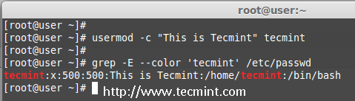](https://www.tecmint.com/wp-content/uploads/2014/11/Add-Information-to-User.png)Add Information to User

**2. Change User Home Directory**

In the above step we can see that our home directory is under **/home/tecmint/**, If we need to change it to some other directory we can change it using **-d** option with usermod command.

For example, I want to change our home directory to **/var/www/**, but before changing, let’s check the current home directory of a user, using the following command.

# grep -E --color '/home/tecmint' /etc/passwd

tecmint:x:500:500:This is Tecmint:**/home/tecmint**:/bin/sh

Now, change home directory from **/home/tecmint** to **/var/www/** and confirm the home director after changing.

# usermod -d /var/www/ tecmint

# grep -E --color '/var/www/' /etc/passwd

tecmint:x:500:500:This is Tecmint:**/var/www**:/bin/sh

[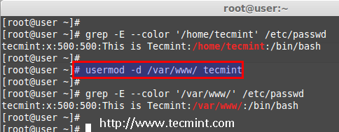](https://www.tecmint.com/wp-content/uploads/2014/11/Change-User-Home-Directory.png)Change User Home Directory

**3. Set User Account Expiry Date**

The option ‘**-e**‘ is used to set expiry date on a user account with the date format **YYYY-MM-DD**. Before, setting up an expiry date on a user, let’s first check the current account expiry status using the ‘**chage**‘ (change user password expiry information) command.

# chage -l tecmint

Last password change : Nov 02, 2014

Password expires : never

Password inactive : never

Account expires : **Dec 01, 2014**

Minimum number of days between password change : 0

Maximum number of days between password change : 99999

Number of days of warning before password expires : 7

The expiry status of a ‘**tecmint**‘ user is **Dec 1 2014**, let’s change it to **Nov 1 2014** using ‘**usermod -e**‘ option and confirm the expiry date with ‘**chage**‘ command.

# usermod -e 2014-11-01 tecmint

# chage -l tecmint

Last password change : Nov 02, 2014

Password expires : never

Password inactive : never

Account expires : **Nov 01, 2014**

Minimum number of days between password change : 0

Maximum number of days between password change : 99999

Number of days of warning before password expires : 7

[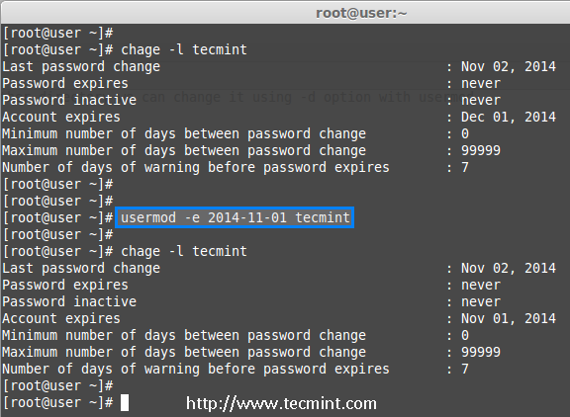](https://www.tecmint.com/wp-content/uploads/2014/11/Set-User-Account-Expiry-Date.png)Set User Account Expiry Date

**4. Change User Primary Group**

To set or change a user primary group, we use option ‘**-g**‘ with usermod command. Before, changing user primary group, first make sure to check the current group for the user **tecmint_test**.

# id tecmint_test

uid=501(tecmint_test) gid=502(**tecmint_test**) groups=502(tecmint_test)

Now, set the **babin** group as a primary group to user **tecmint_test** and confirm the changes.

# usermod -g babin tecmint_test

# id tecmint_test

uid=501(tecmint_test) gid=502(**babin**) groups=502(tecmint_test)

[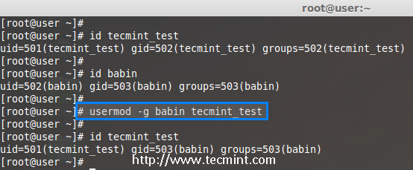](https://www.tecmint.com/wp-content/uploads/2014/11/Change-User-Primary-Group.png)Change User Primary Group

**5. Adding Group to an Existing User**

If you want to add a new group called ‘**tecmint_test0**‘ to ‘**tecmint**‘ user, you can use option ‘**-G**‘ with usermod command as shown below.

# usermod -G tecmint_test0 tecmint

# id tecmint

[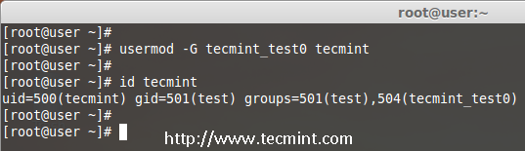](https://www.tecmint.com/wp-content/uploads/2014/11/Add-Group-to-User.png)Add Group to User

**Note**: Be careful, while adding a new groups to an existing user with ‘**-G’** option alone, will remove all existing groups that user belongs. So, always add the ‘**-a**‘ (append) with ‘**-G**‘ option to add or append new groups.

**6. Adding Supplementary and Primary Group to User**

If you need to add a user to any one of the supplementary group, you can use the options ‘**-a**‘ and ‘**-G**‘. For example, here we going to add a user account **tecmint_test0** with the **wheel** user.

# usermod -a -G wheel tecmint_test0

# id tecmint_test0

So, user **tecmint_test0** remains in its primary group and also in secondary group (**wheel**). This will make my normal user account to execute any root privileged commands in Linux box.

eg : sudo service httpd restart

[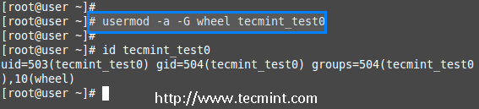](https://www.tecmint.com/wp-content/uploads/2014/11/Add-Multiple-Groups-to-User.png)Add Multiple Groups to User

**7. Change User Login Name**

To change any existing user login name, we can use ‘**-l**‘ (new login) option. In the example below, we changing login name **tecmint** to **tecmint_admin**. So the username **tecmint** has been renamed with the new name **tecmint_admin**.

# usermod -l tecmint_admin tecmint

Now check for the **tecmint** user, It will not be present because we have changed it to **tecmint_admin**.

# id tecmint

Check for the **tecmint_admin** account it will be there with same **UID** and with existing group what we have added before.

# id tecmint_admin

[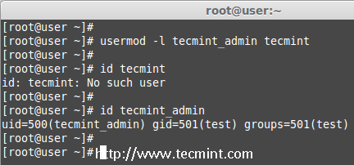](https://www.tecmint.com/wp-content/uploads/2014/11/Change-User-Login-Name.png)Change User Login Name

**8. Lock User Account**

To Lock any system user account, we can use ‘**-L**‘ (lock) option, After the account is locked we can’t login by using the password and you will see a **!** added before the encrypted password in **/etc/shadow** file, means password disabled.

# usermod -L babin

Check for the locked account.

# grep -E --color 'babin' cat /etc/shadow

[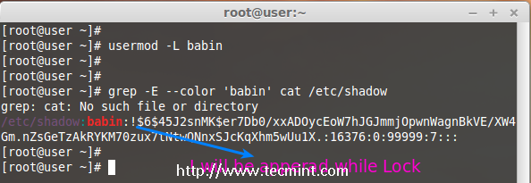](https://www.tecmint.com/wp-content/uploads/2014/11/Lock-User-Account.png)Lock User Account

**9. Unlock User Account**

The ‘**-U**‘ option is used to unlock any locked user, this will remove the **!** before the encrypted password.

# grep -E --color 'babin' /etc/shadow

# usermod -U babin

Verify the user after unlock.

# grep -E --color 'babin' /etc/shadow

[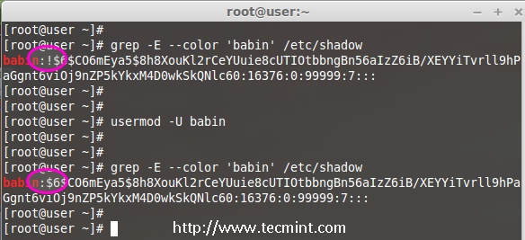](https://www.tecmint.com/wp-content/uploads/2014/11/Unlock-User-Account.png)Unlock User Account

**10. Move User Home Directory to New location**

Let’s say you’ve a user account as ‘**pinky**‘ with home directory ‘**/home/pinky**‘, you want to move to new location say ‘**/var/pinky**‘. You can use the options ‘**-d**‘ and ‘**-m**‘ to move the existing user files from current home directory to a new home directory.

Check for the account and it’s current home directory.

# grep -E --color 'pinky' /etc/passwd

Then list the files which is owned by user pinky.

# ls -l /home/pinky/

Now we have to move the home directory from **/home/pinky** to **/var/pinky**.

# usermod -d /var/pinky/ -m pinky

Next, verify the directory change.

# grep -E --color 'pinky' /etc/passwd

Check for the files under ‘**/home/pinky**‘. Here we have moved the files using**-m** option so there will be no files. The pinky user files will be now under **/var/pinky**.

# ls -l /home/pinky/

# ls -l /var/pinky/

[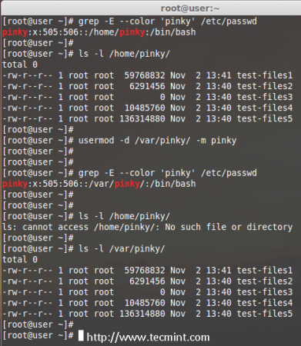](https://www.tecmint.com/wp-content/uploads/2014/11/Move-User-Home-Directory.png)Move User Home Directory

**11. Create Un-encrypted Password for User**

To create an un-encrypted password, we use option ‘**-p**‘ (password). For demonstration purpose, I’m setting a new password say ‘**redha**t’ on a user **pinky**.

# usermod -p redhat pinky

After setting password, now check the shadow file to see whether its in encrypted format or un-encrypted.

# grep -E --color 'pinky' /etc/shadow

[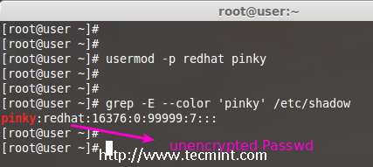](https://www.tecmint.com/wp-content/uploads/2014/11/Create-Unencrypted-User-Password.png)Create Unencrypted User Password

**Note**: Did you see in the above image, the password is clearly visible to everyone. So, this option is not recommended to use, because the password will be visible to all users.

**12. Change User Shell**

The user login shell can be changed or defined during user creation with **useradd** command or changed with ‘**usermod**‘ command using option ‘**-s**‘ (shell). For example, the user ‘**babin**‘ has the **/bin/bash** shell by default, now I want to change it to **/bin/sh**.

# grep -E --color 'babin' /etc/passwd

# usermod -s /bin/sh babin

After changing user shell, verify the user shell using the following command.

# grep -E --color 'babin' /etc/passwd

[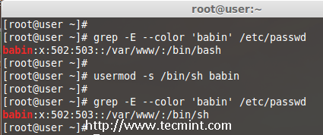](https://www.tecmint.com/wp-content/uploads/2014/11/Change-User-Login-Shell.png)Change User Login Shell

**13. Change User ID (UID)**

In the example below, you can see that my user account ‘**babin**‘ holds the UID of **502**, now I want to change it to **888** as my UID. We can assign UID between **0** to **999**.

# grep -E --color 'babin' /etc/passwd

OR

# id babin

Now, let’s change the UID for user **babin** using ‘**-u**‘ (uid) option and verify the changes.

# usermod -u 888 babin

# id babin

[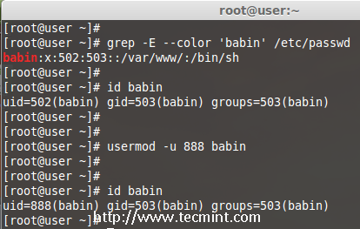](https://www.tecmint.com/wp-content/uploads/2014/11/Change-User-UID.png)Change User UID

**14. Modifying User Account with Multiple Options**

Here we have a user **jack** and now I want to modify his home directory, shell, expiry date, label, UID and group at once using one single command with all options as we discussed above.

The user **Jack** has the default home directory **/home/jack**, Now I want to change it to **/var/www/html** and assign his shell as **bash**, set expiry date as December 10th 2014, add new label as **This is jack**, change UID to 555 and he will be member of apple group.

Let we see how to modify the jack account using multiple option now.

# usermod -d /var/www/html/ -s /bin/bash -e 2014-12-10 -c "This is Jack" -u 555 -aG apple jack

Then check for the UID & home directory changes.

# grep -E --color 'jack' /etc/passwd

Account expire check.

# chage -l jack

Check for the group which all jack have been member.

# grep -E --color 'jack' /etc/group

[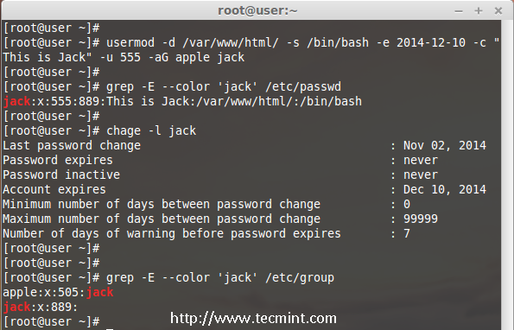](https://www.tecmint.com/wp-content/uploads/2014/11/Usermod-Command-Options.png)Using Multiple Options with usermod

**15. Change UID and GID of a User**

We can change UID and GID of a current user. For changing to a New GID we need an existing group. Here already there is an account named as **orange** with GID of **777**.

Now my jack user account want to be assigned with UID of **666** and GID of Orange (**777**).

Check for the current UID and GID before modifying.

# id jack

Modify the UID and GID.

# usermod -u 666 -g 777 jack

Check for the changes.

# id jack

[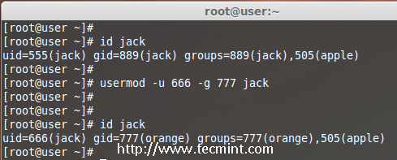](https://www.tecmint.com/wp-content/uploads/2014/11/Change-User-GID.png)Change User UID and GID

**Conclusion**

Here we have seen how to use usermod command with its options in very detailed fashion, Before knowing about usermod command, one should must know ‘useradd’ command and its options to use the usermod. If I’ve missed any point in the article do let me know via comments and don’t forget to add your valuable comments.